**1. What do you mean by BI? Explain.**

**Ans:**

Business intelligence (BI) refers to the procedural and technical infrastructure that collects, stores, and analyzes the data produced by a company’s activities.

BI is a broad term that encompasses data mining, process analysis, performance benchmarking, and descriptive analytics. BI parses all the data generated by a business and presents easy-to-digest reports, performance measures, and trends that inform management decisions.

* Types of BI Tools and Software

BI tools and software come in a wide variety of forms. Let's take a quick look at some common types of BI solutions.

* Spreadsheets: Spreadsheets like Microsoft Excel and Google Docs are some of the most widely used BI tools.
* Reporting software: Reporting software is used to report, organize, filter, and display data.
* Data visualization software: Data visualization software translates datasets into easy-to-read, visually appealing graphical representations to quickly gain insights.
* Data mining tools: Data mining tools "mine" large amounts of data for patterns using things like artificial intelligence, machine learning, and statistics.
* Online analytical processing (OLAP): OLAP tools allow users to analyze datasets from a wide variety of angles based on different business perspectives.

-> Benefits of Business Intelligence:

There are many reasons why companies adopt BI. Many use it to support functions as diverse as hiring, compliance, production, and marketing. BI is a core business value; it is difficult to find a business area that does not benefit from better information to work with.

Some of the many benefits companies can experience after adopting BI into their business models include faster, more accurate reporting and analysis, improved data quality, better employee satisfaction, reduced costs, and increased revenues, and the ability to make better business decisions.

**2. How Power-BI helps in BI, and how does it help Analysts? Explain.**

**Ans:**

**Microsoft Power BI** is a data visualization platform used primarily for business intelligence purposes. Designed to be used by business professionals with varying levels of data knowledge, Power BI’s dashboard is capable of reporting and visualizing data in a wide range of different styles, including graphs, maps, charts, scatter plots, and more.

Power BI itself is composed of several interrelated applications: Power BI Desktop, Pro, Premium, Mobile, Embedded, and Report Server. While some of these applications are free-to-use, paid subscriptions to the pro and premium versions provide greater analytics capabilities.

Power BI is also a part of Microsoft’s Power Platform, which includes Power Apps, Power Pages, Power Automate, and Power Virtual Agents. Created as “low-code tools,” these applications help businesses analyze and visualize data, design business solutions, automate processes, and create no-code chatbots.

**Power BI uses**: Whether you’re a bona fide data pro or are just entering the business world, Power BI is designed to empower you with data-driven insights. Some of the most common uses for the platform include:

* Creating reports and dashboards that present data sets in multiple ways using visuals
* Connecting various data sources, such as Excel sheets, onsite data warehouses, and cloud-based data storage, and then transforming them into business insights
* Turning data into a wide range of different visuals, including pie charts, decomposition trees, gauge charts, KPIs, combo charts, bar and column charts, and ribbon charts – among many other options
* Providing company-wide access to data, data visualization tools, and insights in order to create a data-driven work culture

**3. Explain Descriptive analytics?**

**Ans:**

Descriptive analytics is the process of using current and historical data to identify trends and relationships. It’s sometimes called the simplest form of data analysis because it describes trends and relationships but doesn’t dig deeper.

Descriptive analytics is relatively accessible and likely something your organization uses daily. Basic statistical software, such as Microsoft Excel or data visualization tools, such as Google Charts and Tableau, can help parse data, identify trends and relationships between variables, and visually display information.

Descriptive analytics is especially useful for communicating change over time and uses trends as a springboard for further analysis to drive decision-making.

**EXAMPLES OF DESCRIPTIVE ANALYTICS**:

1. Traffic and Engagement Reports
2. Financial Statement Analysis
3. Demand Trends
4. Aggregated Survey Results
5. Progress to Goals

**4. Explain Predictive analytics?**

**Ans:**

The term **predictive analytics** refers to the use of statistics and modeling techniques to make predictions about future outcomes and performance. Predictive analytics looks at current and historical data patterns to determine if those patterns are likely to emerge again. This allows businesses and investors to adjust where they use their resources to take advantage of possible future events. Predictive analysis can also be used to improve operational efficiencies and reduce risk.

**Understanding Predictive Analytics** Predictive analytics is a form of technology that makes predictions about certain unknowns in the future. It draws on a series of techniques to make these determinations, including artificial intelligence (AI), data mining, machine learning, modeling, and statistics. 1 For instance, data mining involves the analysis of large sets of data to detect patterns from it. Text analysis does the same, except for large blocks of text.

Predictive models are used for all kinds of applications, including weather forecasts, creating video games, translating voice to text, customer service, and investment portfolio strategies. All of these applications use descriptive statistical models of existing data to make predictions about future data.

**Uses of Predictive Analytics**

1. Forecasting
2. Credit scoring
3. Supply Chain
4. Human Resources
5. Fraud Detection

**5. Explain Perspective analytics?**

**Ans:**

Prescriptive analytics is the process of using data to determine an optimal course of action. By considering all relevant factors, this type of analysis yields recommendations for next steps. Because of this, prescriptive analytics is a valuable tool for data-driven decision-making.

Machine-learning algorithms are often used in prescriptive analytics to parse through large amounts of data faster—and often more efficiently—than humans can. Using “if” and “else” statements, algorithms comb through data and make recommendations based on a specific combination of requirements. For instance, if at least 50 percent of customers in a dataset selected that they were “very unsatisfied” with your customer service team, the algorithm may recommend additional training.

**EXAMPLES OF PRESCRIPTIVE ANALYTICS IN ACTION**

1. Venture Capital: Investment Decisions
2. Sales: Lead Scoring
3. Content Curation: Algorithmic Recommendations
4. Banking: Fraud Detection
5. Product Management: Development and Improvement
6. Marketing: Email Automation

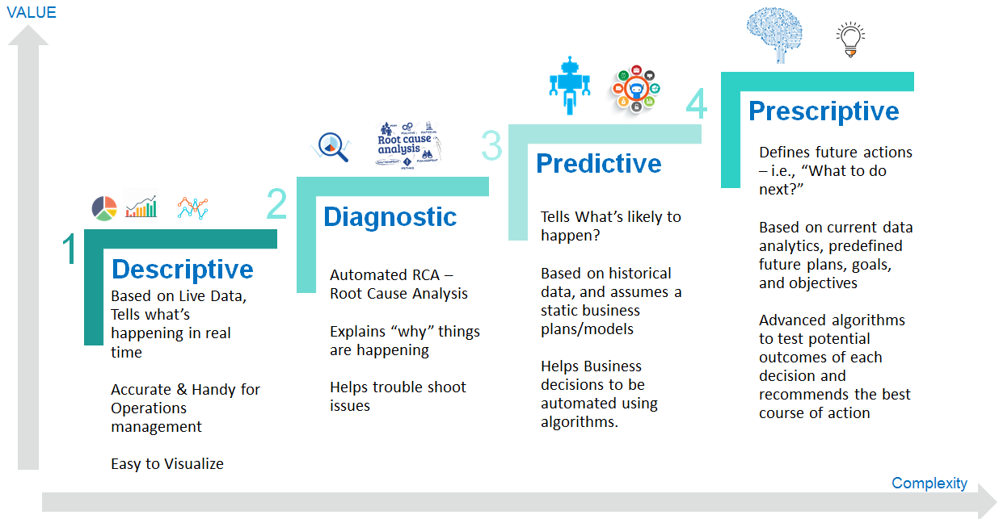

**6. Write five real-life questions that PowerBi can solve.**

**Ans:**

1. Sales Analysis Report
2. Human Resource Reports
3. Customer Profitability Reports
4. Digital Marketing Reports
5. Financial Analysis Reports